图像测量利用了摄像头成像，也就是小孔成像的几个性质。摄像头把平行的直线为图像上的相交的直线。也就是说，平行直线在无限远处相交，这些交点构成了地平线。  
摄像头把三维空间投影到二维图像上，保持直线交比不变，也就是说如果在三维空间中的一条直线上有四个点，那么它映射到图片上的四个点的交臂是不变的。文献#通过这些条件给出了，从图片上计算长度的公式。以下给服务我们计算长度的流程。  
例如我们需要通过照片求出小人的身高，已知蓝色小人的身高。为了简化模型，我们把人物简化为一条线段，用小写字母表是照片中的成像，大写字母表示的是实际的点。  
  
从图中可知，ADEB为平行四边形，我们已知EB的长度，可以得知AD的长度，要求AF的长度，我们需要求的是XXX.  
  
做 de的延长线与 ab 的延长线在无穷远处交于c点，作eb的延长线与da的延长线，在无穷远处交于点g。  
  
abed也就是真实空间中平形四边形ABED的像。  
  
然而，即使知道了某些线段在图像上的像，它们的实际长度无法从图像上测量得出，因为每一个点的深度不一样。这时就要利用成像前后一条直线上4个点交比不变的性质，考察A D F及其延长到无穷远处的点G的比例，可以得出  
(AD/AF)/(GD/GF)=(ad/af)/(gd/gf)  
  
因为已经求出了ad的长度，等式右边所有的量都可以从图像上测出等式，左边的点G在真实空间中是所有垂直直线的交点，这个点在无穷远处，因此，基地比GD/GF=1，这样就可以得到最终结果

AD/AF=(ad/af)/(gd/gf)

Reference:

The derivation process of the width of slab

Image measurement uses several properties of camera imaging, that is, small hole imaging. The camera treats parallel lines as intersecting lines on the image. In other words, parallel lines intersect at infinity, and these intersections form the horizon.The camera projects the three-dimensional space onto the two-dimensional image, keeping the straight line cross ratio unchanged. That is to say, if there are four points on a straight line in the three-dimensional space, then the intersection of the four points mapped to the picture is not changing. Literature# gives the formula for calculating the length from the picture through these conditions. The following gives us the process of calculating the length.

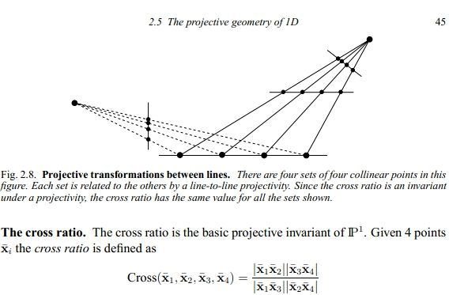

For example, we need to find the height of the villain through photos, and the height of the blue villain is known. In order to simplify the model, we simplified the character into a line segment, using lowercase letters to represent the image in the photo, and uppercase letters to represent actual points.

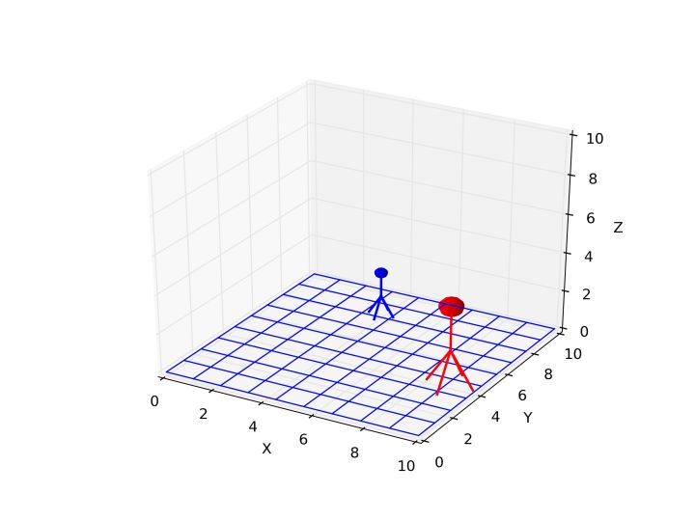

It can be seen from the figure that **ADEB** is a parallelogram. We know the length of **EB**, we can know the length of **AD**, and the length of **AF** is required. What we need is **AD/AF.**

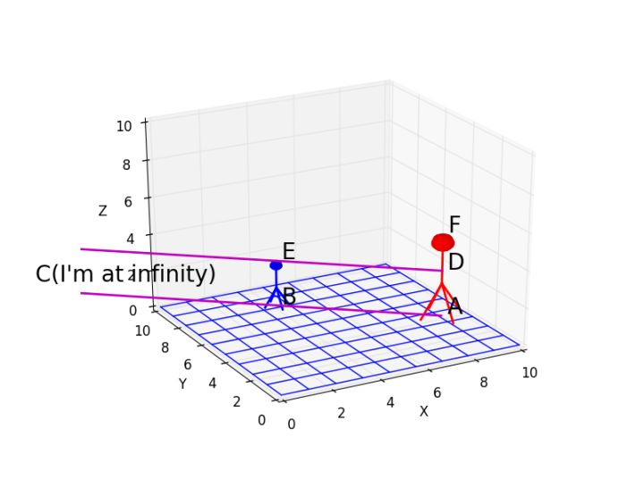

The extension line of **de** and the extension line of ab intersect at point c at infinity, and the extension line of **eb** and **da** intersect at point g at infinity.

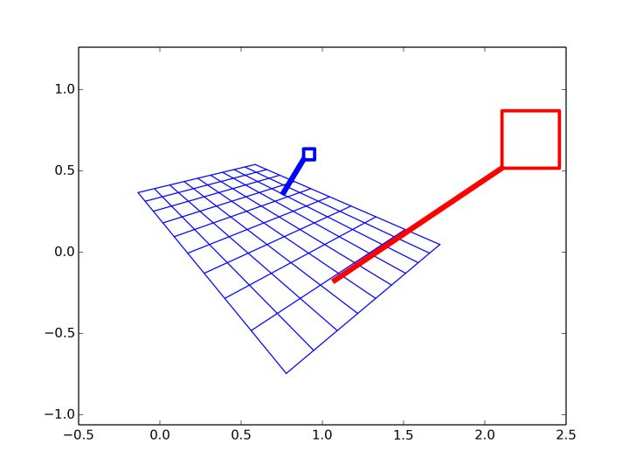

abed is the image of the flat quadrilateral **ABED** in real space.

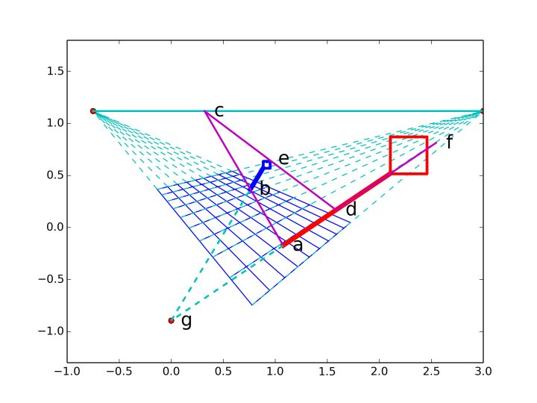

However, even if you know the image of certain line segments on the image, their actual length cannot be measured from the image because the depth of each point is different. At this time, we need to use the property that the intersection ratio of 4 points on a straight line before and after imaging is constant, and examine the ratio of A D F and the point G extending to infinity, we can get

**(AD/AF)/(GD/GF)=(ad/af)/(gd/gf)**

Because the length of ad has been calculated, all the quantities on the right side of the equation can be measured from the image. The point G on the left is the intersection of all vertical straight lines in real space. This point is at infinity. Therefore, the base Ratio **GD/GF=1**, so you can get the final result

**AD/AF=(ad/af)/(gd/gf)**

In this question, Wc/W=(ad/af)/(gd/gf)

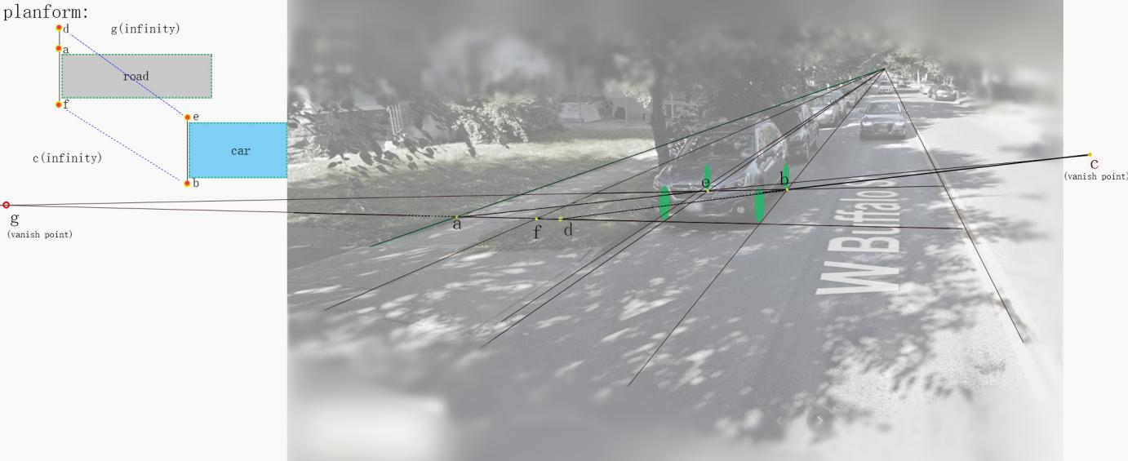

By investigating the make and model of the car in the picture, we know that the car in the picture is called Subaru-Outback, with a width of Wc=1.84 meters.



[#] Criminisi A, Reid I, Zisserman A. Single view metrology[j]. International Jornal of Computer Vision, 2000, 40 (2):123-148.

[车]https://price.pcauto.com.cn/price/nb49/#ad=8099

https://price.pcauto.com.cn/sg1994/